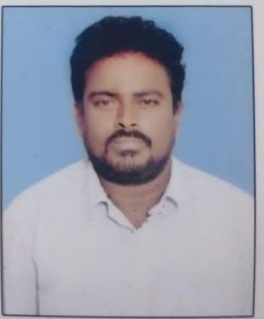**Faculty Profile**

|  |  |
| --- | --- |
| Name &Address | Palika Barillu,  Lecturer in History, GDC, Ramachandrapuram |
| Educational Qualifications | M.A.,B.Ed, APSET |
| Teaching Experience | 3 years |
| Research Experience | NIL |
| Present Post & Responsibilities held | Guest lecturer in History |
| Professional Training Programs attended | NIL |
| Publications in Journals | NIL |
| Paper Presentations in Seminars &Conferences | NIL |
| Workshops/Trainings attended | NIL |
| FDPs attended | NIL |
| National /International Seminars attended | NIL |
| Awards /Honours | NIL |
| Research Guideship | NIL |
| Membership in Professional Organizations | NIL |
| MOOCS Enrolled/Completed | NIL |
| Any other Information | NIL |